08 February 2026, Sunday World, page 10: News
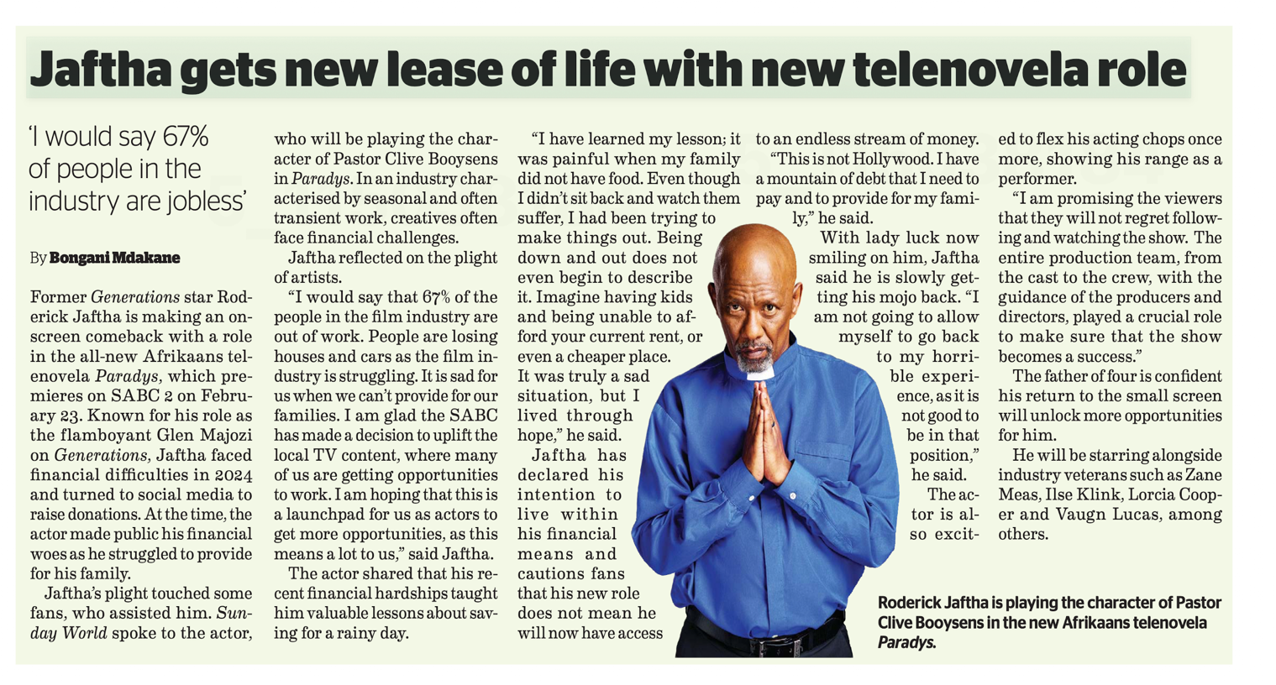

1. Vulnerability is a Strength, Not a Weakness
Traditionally, men are taught to suffer in silence to maintain an image of "strength." Jaftha broke this mold by going public with his struggles.
- The Lesson: Real strength lies in the courage to admit when you are failing. By being honest about his "mountain of debt" and his family’s lack of food, he invited community support rather than isolating himself in shame.
2. Redefining the "Provider" Role
The pressure to be a sole provider can lead to immense mental health struggles when financial stability falters. Jaftha’s story highlights the transition from ego-driven providing to humility-driven survival.
- The Lesson: Masculinity isn't about being "invincible" in business; it’s about doing whatever it takes to care for your loved ones, including asking for help and accepting "smaller" or different roles to get back on your feet.
3. Financial Accountability and Prudence
Jaftha candidly admits he learned "valuable lessons about saving for a rainy day." He warns that a new job doesn't mean "an endless stream of money."
- The Lesson: Positive masculinity involves stewardship. It is about managing resources wisely to ensure long-term stability for one's family, rather than projecting an image of wealth that isn't sustainable.
4. Resilience Through "Mojo" and Mindset
Despite being "down and out," Jaftha maintained his passion for his craft. He views his new role in Paradys as a launchpad rather than just a paycheck.
- The Lesson: A man’s value isn't tied to a single moment of failure. Resilience—the ability to "get one's mojo back" and flex one's "acting chops" again—is a core tenet of a healthy, growth-oriented masculine identity.
5. Community and Collaboration
Jaftha credits his fans, the SABC, and his colleagues for his comeback. He doesn't frame his return as a "lone wolf" victory but as part of a collective effort.
- The Lesson: Success is a team sport. Recognizing the "guidance of producers" and the "entire production team" shows a level of maturity and gratitude that is central to positive male leadership.

Aspect | Traditional/Toxic Trait | Jaftha’s Positive Masculinity
Handling Failure | Hiding it; Social withdrawal | Transparency; Asking for help
Self-Worth | Based on current status/income | Based on character and resilience
Financials | Spending to maintain image | Saving and living within means
Collaboration | Hyper-independence | Gratitude and teamwork

